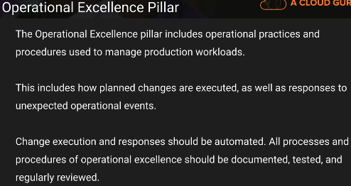

Documentation up to date..

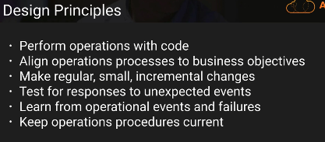

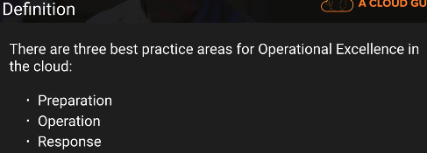

Preparation:

Pre-requisites check..

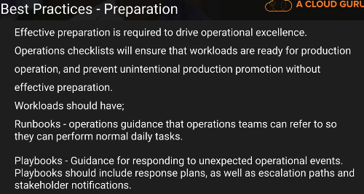

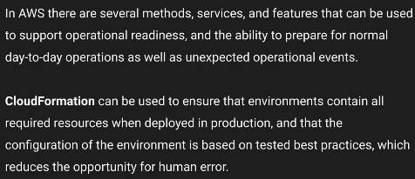

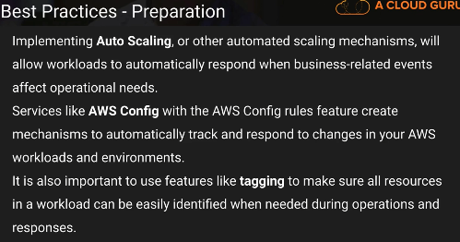

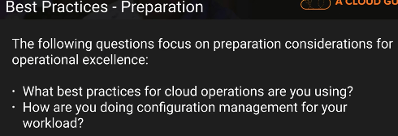

Documentation – updated

                                Audit documentation..

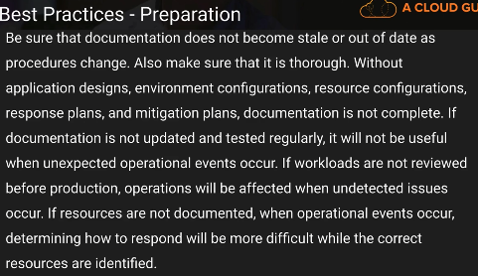

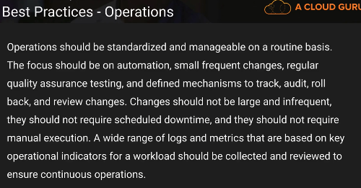

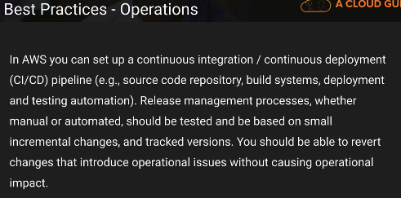

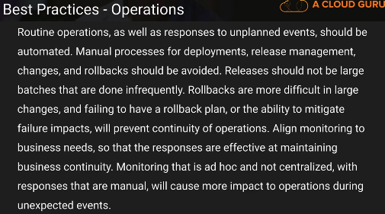

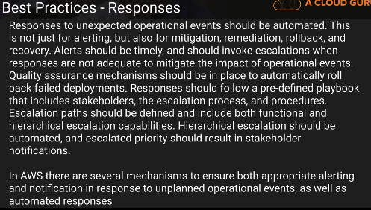

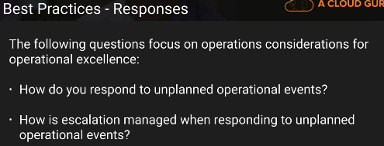

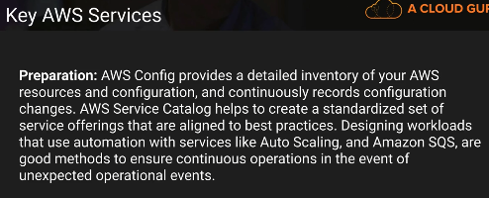

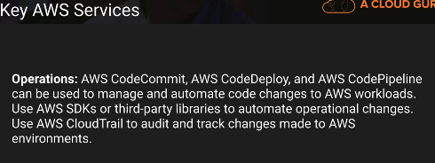

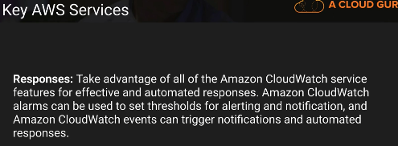

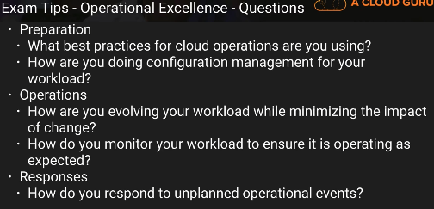

Thanks & Regards,

Shantaram Vernekar

Design Principles

There are five design principles for operational excellence in the cloud:

Perform operations as code

You can script your operations procedures and automate their execution by triggering them in response to events.

By performing operations as code, you limit human error and enable consistent responses to events.

Annotated documentation

Manual documentation - hard to keep in sync with the pace of change

you can automate the creation of annotated documentation after every build

Annotated documentation can used by humans and systems. Use annotations as an input to your operations code

Make frequent, small, reversible changes

Make changes in small increments that can be reversed if they fail

Refine operations procedures frequently

Improve procedures

Set up regular Game Days to review and validate that all procedures are effective and that teams are familiar with them

Anticipate failure

identify potential sources of failure

Test your failure scenarios and validate your understanding of their impact. Test your response procedures to ensure they are effective and that teams are familiar with their execution

Learn from all operational failures

Definition

Operational excellence in the cloud is composed of three areas: • Prepare • Operate • Evolve

**Prepare**

To prepare for operational excellence, you need to consider the following: • Operational priorities • Design for operations • Operational readiness

Operational Priorities

understanding of your entire workload, their role in it, and shared business goals in order to set the priorities that will enable business success

**Key Services**

* **AWS Cloud Compliance** enables you to understand the robust controls in place at AWS to maintain security and data protection in the cloud.
* **AWS Trusted Advisor** provides real-time guidance to help you provision your resources following AWS best practices.
* **Business Support** provides access to the full set of Trusted Advisor checks and guidance to provision your resources following AWS best practices.
* Enterprise Support customers also receive support from **Technical Account Managers (TAMs)** who, as designated technical points of contact, provide guidance to help you plan and build solutions using best practices, and proactively keep your AWS environment operationally healthy

Design for Operations

The design of your workload should include how it will be deployed, updated, and operated.

To understand what is happening inside your architecture, you will need to enable observation with logging, instrumentation, and insightful business and technical metrics

**Key Service** : **CloudWatch**

* **AWS CloudFormation** allows you to create version-controlled standardized templates for your infrastructure.
* **AWS Developer Tools** is a set of services enabling rapid and safe delivery of software.  CICD - AWS CodeCommit, AWS CodeBuild, AWS CodePipeline, AWS CodeDeploy, and AWS CodeStar
* **AWS X-Ray** traces user requests as they travel through your entire application, enabling analysis and debugging of distributed applications

Operational Readiness

consistent process (including checklists) to know when you are ready to go live with your workload

AWS allows you to treat your operations as code, scripting your runbook and playbook activities to reduce the risk of human error.

**Key Service** : **AWS Lambda**

enables the definition of operational procedures as code that can be triggered by events within your environment

Others:

* AWS Config allows you to track changes to your deployed CloudFormation stacks. With AWS Config rules you can evaluate whether your AWS resources comply with best practices.
* Amazon EC2 Systems Manager is a collection of capabilities that helps you automate management tasks on your Amazon Elastic Compute Cloud (Amazon EC2) instances.

**Operate**

By understanding the operational health of your workload, you can identify when it is impacted by operational events and respond appropriately.

To operate successfully, you need to consider the following: • Understanding operational Health • Responding to Events

Understanding Operational Health

Health of environment using dashboards

has support for third-party log analysis systems and business intelligence tools through the AWS service APIs and SDKs (for example, Grafana, Kibana, and Logstash).

**Key Service** : **CloudWatch**

**Others**

* **Amazon CloudWatch Logs** allows you to monitor and store logs from EC2 instances, AWS CloudTrail, and other sources.
* **Amazon ES** makes it easy to deploy, secure, operate, and scale Elasticsearch for log analytics, and application monitoring.
* **Personal Health Dashboard** provides alerts and remediation guidance when AWS is experiencing events that may impact you.
* **Service Health Dashboard** provides up-to-the-minute information on AWS service availability.

Responding to Events

**Key Service** : **AWS Lambda**

**Others**

Amazon CloudWatch is used for the collection of logs and metrics. It enables the triggered execution of responses.

Amazon CloudWatch Events delivers a near real-time stream of system events that can be matched to rules you define to trigger automated responses.

Amazon SNS is a flexible, fully managed publication subscription messaging and mobile notifications service for coordinating the delivery of messages to subscribing endpoints and clients. It enables you invoke Lambda functions in response to alarms.

Auto Scaling helps you maintain application availability and allows you to dynamically scale your Amazon EC2 capacity up or down automatically according to conditions you define.

Amazon EC2 Systems Manager is a collection of capabilities that helps you automate management tasks on your EC2 instances.

**Evolve**

Evolution is the continuous cycle of improvement over time. Implement frequent small incremental changes based on the lessons learned from your operations activities.

To evolve your operations over time, you need to consider the following: • Learning from experience • Sharing learnings

Learning from Experience

**Key Service** : Elastic Search

Amazon QuickSight is a business analytics service that makes it easy to build visualizations, perform ad-hoc analysis, and quickly get insights from your data.

Amazon Athena is a serverless interactive query service that makes it easy to analyze data in Amazon S3.

Amazon S3 can be used for collection and archival retention of logs.

Amazon CloudWatch is used for the collection of logs and metrics and the creation of dashboards.

Sharing learnings

**Key Service** : IAM

Amazon SNS enables event-based notification of publishing of resources to subscribers.

AWS CodeCommit provides a version-controlled repository for your operations as code that can be shared through IAM.

AWS Lambda enables the definition of operational procedures as code that can be shared across accounts.

AWS CloudFormation allows you to create version-controlled standardized templates for your infrastructure.

Amazon Machine Images (AMIs) are predefined operating system templates for your EC2 compute environments.